Chapter 6, Solution 47.

Under dc conditions, the circuit is equivalent to that shown below:
R
2 Ω
i_{L}
5 A
+ v_{C} −

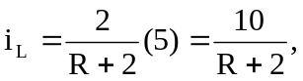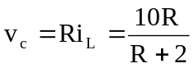

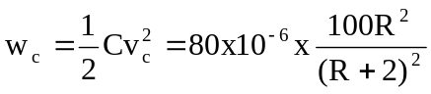
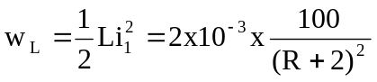
If w_{c} = w_{L},

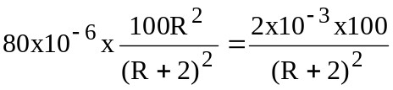 80 x 10⁻³R² = 2

R = 5Ω

